 Assignment Rules: Group Assignment

Investigation Exercise

In this exercise, you will use breakpoints in ClaimCenter Studio to observe the execution of assignment rules.

1. In ClaimCenter Studio, set break points at the first rule in both the Global Claim Assignment rule set and Default Group Claim Assignment rule set.

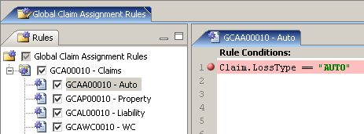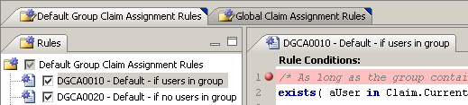

2. Make sure that Studio is connected to ClaimCenter. Then, start the debugger.

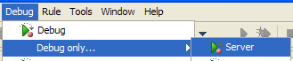

3. Log on to ClaimCenter as Andy Applegate and navigate to a claim. Reassign the claim using "Use automated assignment". Step through the code.

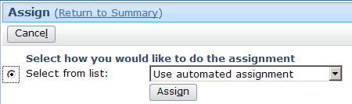

3a) Did the Global Claim rules execute?

3b) Did the Default Group rules execute?
4. Repeat the process, but reassign the claim to the Auto1 - TeamB group. Step through the code.

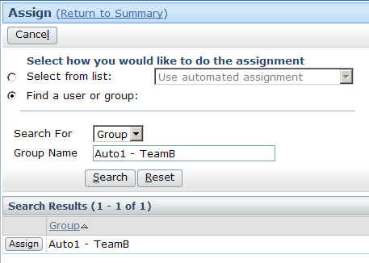

4a) Did the Global Claim rules execute?

4b) Did the Default Group rules execute?

5. Repeat the process, but reassign the claim to Betty Baker in the Auto1 - TeamA group. Step through the code.

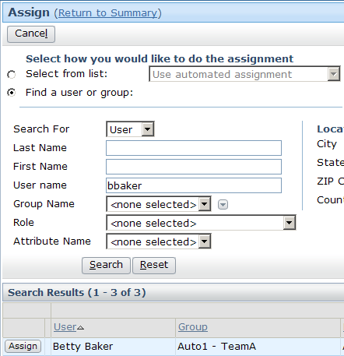

5a) Did the Global Claim rules execute?

5b) Did the Default Group rules execute?
Configuration Exercise

Configure ClaimCenter to meet the following customer requirement from Acme Insurance.

(This lab depends upon the users and groups created in the "Users and Groups" lab.)

Requirement 1: Assigning Complex Theft Claims to Complex Thefts - West

Acme Insurance has two groups which handle auto claims in which the entire car was stolen. As a proof of concept, Acme Insurance wants to see all claims where the entire car was stolen assigned to the Complex Thefts - West group.

6. Write a claim assignment rule that assigns all claims with a loss cause of "Theft of entire vehicle" to the Complex Thefts - West group. (For this requirement, you can ignore the Complex Thefts - East group.)

(Normally, this would probably be done in conjunction with segmentation. A segmentation rule would segment the claim based on loss cause, and the assignment rule would react to the claim's segment. To simplify the lab, you can write the assignment rule to react directly to the loss cause.)

If your class is being taught on a release prior to ClaimCenter 6.0.2, it may be necessary for you to find the public ID of the Complex Thefts - West group in order to complete the assignment rule. If so, copy the following code into the Gosu Tester to get it from ClaimCenter:

// This code assumes the group name is "Complex Thefts - West"
var groupQuery = gw.api.database.Query.make(Group)
groupQuery.compare("Name", Equals, "Complex Thefts - West")
var resultRow = groupQuery.select().AtMostOneRow
print (resultRow.PublicID)

Test Case 1

When you have completed your configuration, run the following test cases:

7. Log on to ClaimCenter as Andy Applegate. Navigate to an auto claim whose loss cause is something other than "theft of entire vehicle". Reassign the claim using assignment rules and verify that the claim goes to a group other than Complex Thefts - West.

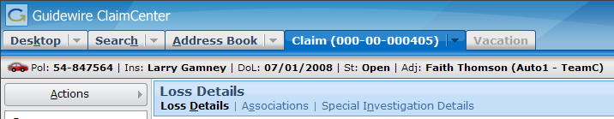

8. Modify the claim so that the loss cause is "theft of entire vehicle". Reassign the claim using assignment rules and verify that the claim now goes to Complex Thefts - West.

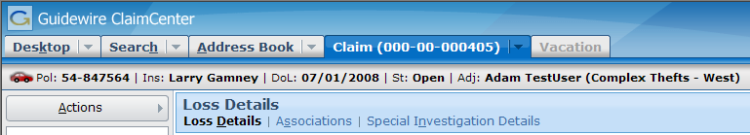

Requirement 2: Assigning Complex Theft Claims Based on Region

The initial proof of concept was successful. Acme Insurance now wants complex theft claims to go to either Complex Thefts - West and Complex Thefts - East, depending on the loss location.

9. Modify the claim assignment rule so that all claims with a loss cause of "Theft of entire vehicle" are assigned to the Complex Theft group for the region in which the loss occurred. (Do not attempt to assign the claim by location if the loss location is null.)

Test Case 2

When you have completed your configuration, run the following test cases:

10. Log on to ClaimCenter as Andy Applegate. Navigate to an auto claim whose loss cause is "theft of entire vehicle" and who loss location is in a western state, such as California. (If necessary, you can simply modify the loss location of a given claim.) Reassign the claim using assignment rules and verify that the claim goes to Complex Thefts - West.

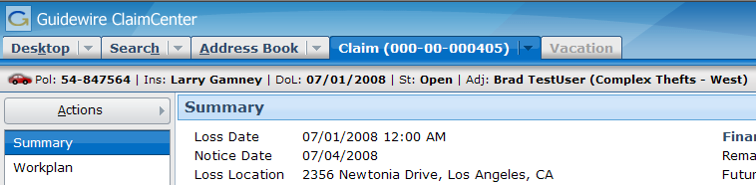

11. Modify the claim so that the loss location is in an eastern state, such as New York. Reassign the claim using assignment rules and verify that the claim now goes to Complex Thefts - East.

